- Antonio Austria
Title “Apartment”
Signed and dated upper right vise versa 1967
30” x 35 ½”
Oil on canvas

- Betsy Westendorp
Signed and dated lower right 1988
24” x 18”
Oil on canvas

- Jose Joya “J Baldovino”
Title “ Mood Swing”
Acrylic on canvas
Dated 2017
48” x 36”

- Florencio Concepcion
Signed and dated lower left 2012
63 1/3” x 48”

- Jeho Bitancor
Signed and dated lower right 2021
Oil on canvas
60” x 48”

- Bryan Teves
Signed and dated lower left 2019
Oil on canvas
48” x 60”

- F Montemayor
Title “Poblacion Dos”
Signed and dated lower left 2016
Acrylic on canvas
- ½” 96”

- Florencio Concepcion
Signed and dated lower left 1968
35” x 35”

1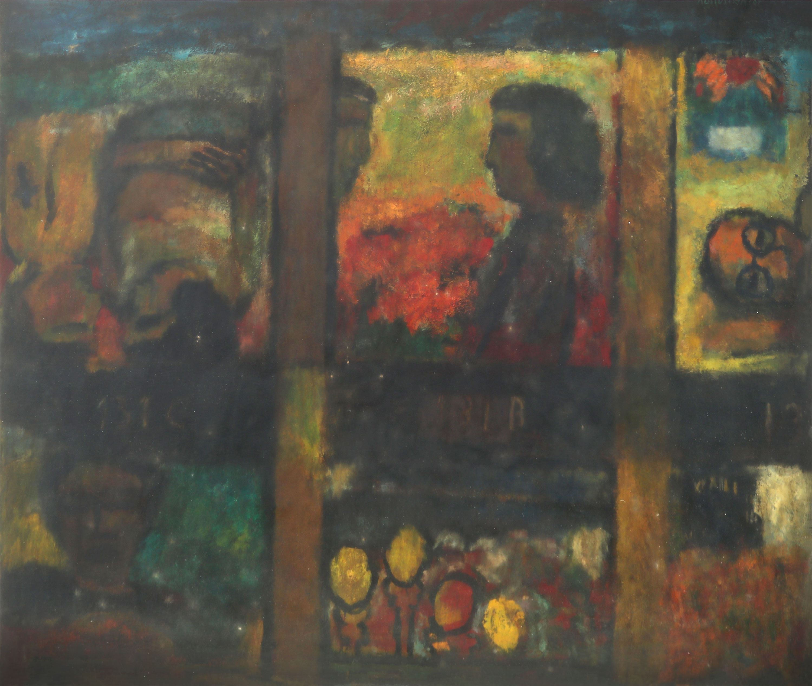

2

3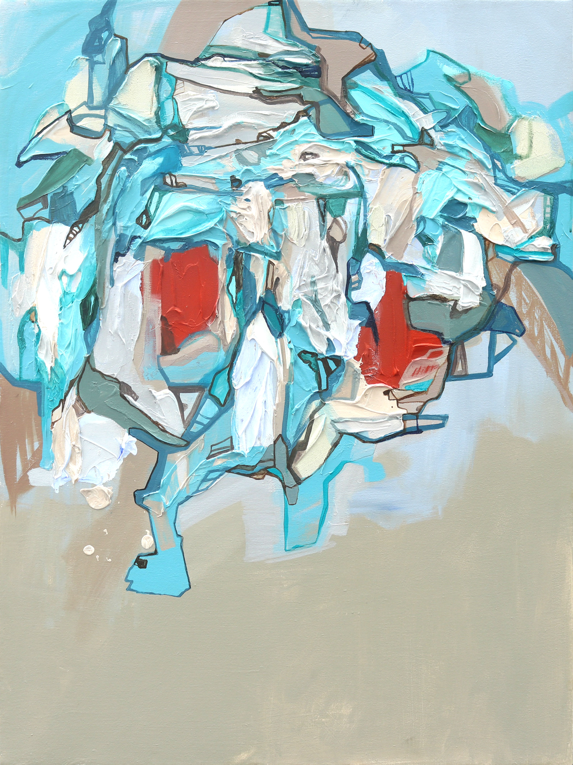
4
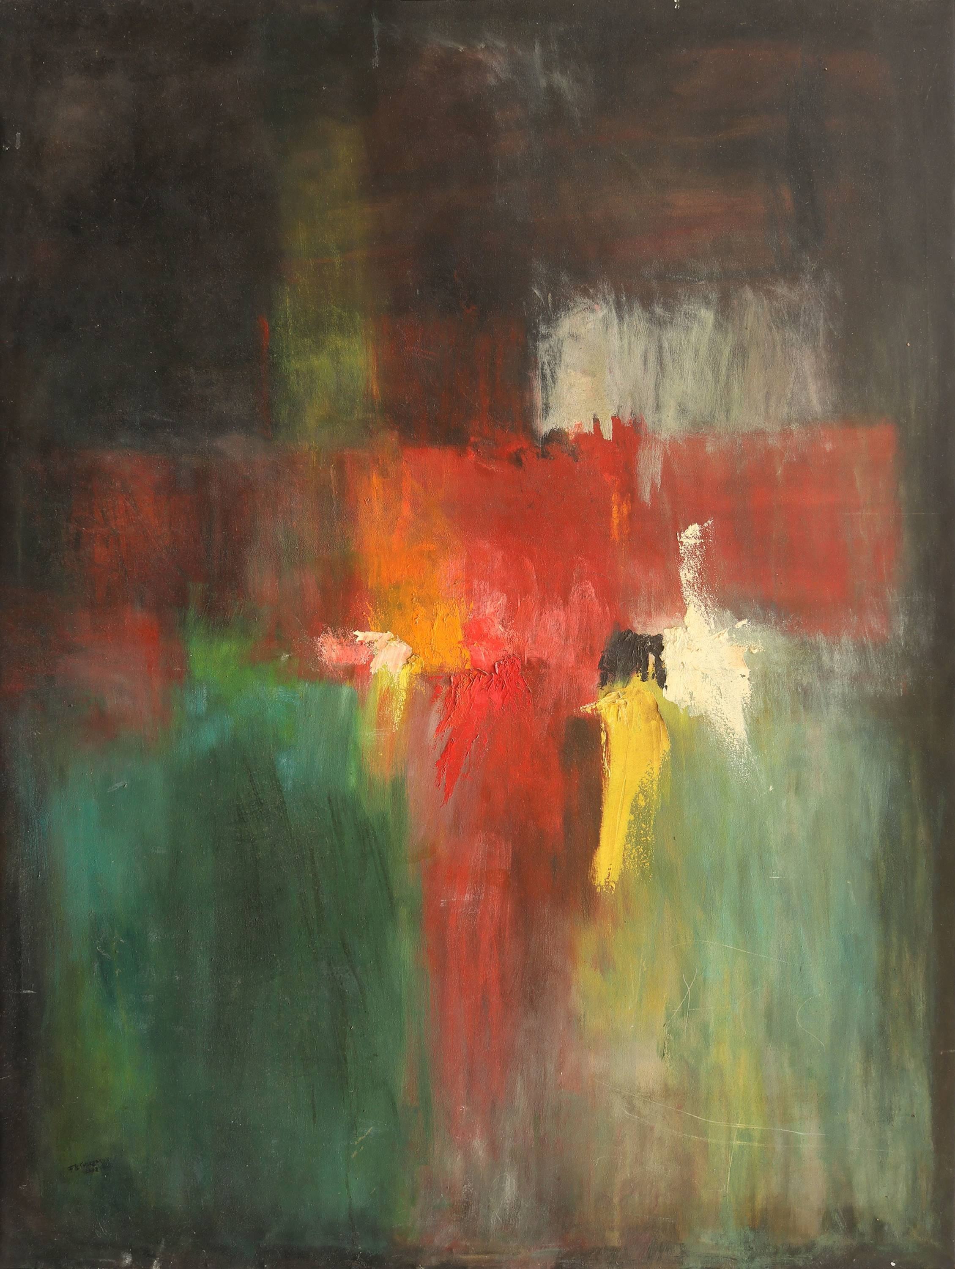

5
6

7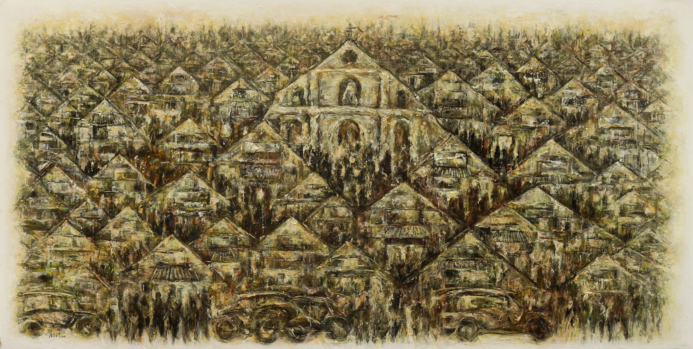
8